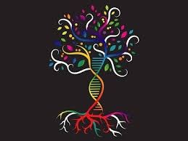
Van Zandt Genealogical Society
Preparation for GEDmatch Workshop
April 27, 2024

Before our GEDmatch Workshop take these few easy steps BEFORE you arrive. These will help create some fun and productive learning! These are optional suggestions. See the “How to” below.

1. | Are we related? Download the FamilySearch.org app on your phone.
2. | Create a free account on GEDmatch.com.
3. | Download your raw DNA data from your testing site (see how below).
4. | Upload your DNA data to GEDmatch.com. A kit # will be generated.
5. | Download your public tree into a “GEDcom” file (to use on GEDmatch.com).
6. | To participate in a “Live” GEDmatch demonstration, bring your kit #!

I. ARE WE RELATED? Download the FamilySearch.org app.
A. Open the Apple App Store or Google Play Store, or go to: https://www.familysearch.org/mobile-apps/
For Kindles, go to Amazon.com and set the search filter to Apps & Games. Or click the tab Appstore for Android. The Get Involved app is not available on the Amazon Appstore.
B. Find for FamilySearch.
- How to locate the desired app from the list.
  - Android: Tap Install.
  - Apple: Tap Get.
  - Kindle: Tap Get App.
- When the app finishes its installation, tap its icon to open it.
https://www.familysearch.org/en/help/helpcenter/article/how-do-i-download-familysearch-mobile-apps
Note: Create a free account and add a few generations to your tree. See if we are related to each other with “Relatives Around Me.”
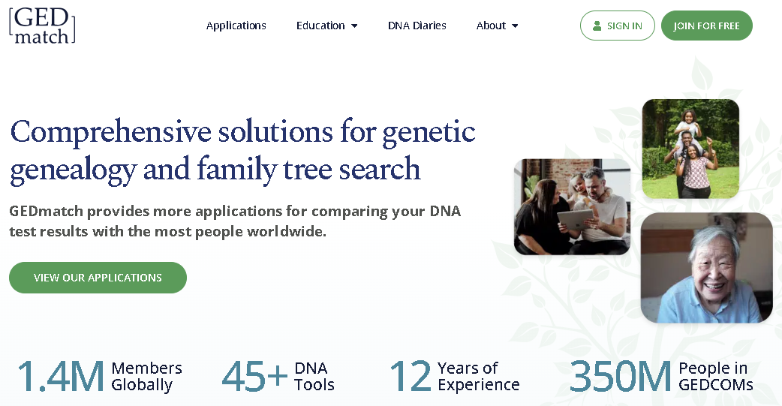
2. Create a free account on GEDmatch.com.

3. Download your raw DNA data from your testing site. (See your testing site below). Remember, only “Autosomal” DNA can be downloaded from your testing site. Y-DNA and mtDNA cannot be used in GEDmatch.com.

4.. Upload to GEDmatch.com

Upload AncestryDNA

1. Log in to Ancestry.com
2. Click on DNA at the top of the page menu
3. Click on “Your results data summary.”
4. Click on “Settings.”
5. Click on “Download raw DNA data.”
6. Enter a checkmark in the box with the statement, “I understand that my … “
7. Enter a password and click on “Confirm...”
8. Follow instructions
The data will download to your computer, probably in the download folder. Leave it there untouched until you find it with your “Browse” button (11 below).
9. Log into GEDmatch.
10. Click on “Generic uploads (23andMe, FTDNA, AncestryDNA, and most others).”
11. Fill in the form with as much information as you have
12. Click on the Browse button at the bottom of the page
13. Find the title of the raw data you downloaded from Ancestry. Hint: look for the correct download date.
14. Highlight the title, then click on open at the bottom of the page where the title occurs. The title will now appear next to your GEDmatch browse button.
15. Click the upload button and wait until you see the word “Finish.”
16. Answer the question (Typically within 24 to 48 hours)
It will take one to two days for your information to fully process to use the database app “One to Many DNA Comparison Result.” Your new GEDmatch kit number can be used for some apps within 20 minutes, such as the “One-to-one Comparison.”

Once the kit is uploaded, you may want to read “How to use GEDmatch” in the information section of your GEDmatch home page.

Upload 23andMe

1. Log into 23andMe
2. On the upper right side, see your name, initials, or picture, followed by a down arrow. Click the down arrow.
3. In the drop-down menu, click on “settings.”
4. In the bottom section titled “23andMe Data,” click on “View.”
5. On the page that appears in the “Raw Data” section, click on “Download Raw Data.”
6. Click on “I understand limitations and risks.”
7. Click on “Submit Request.”

It may take an hour or more for your DNA data to be sent to your email. Once your raw data arrives, do not touch it until you find it using the browse button in the file upload form (see 13 below).

8. When 23andMe notifies you that the data has been sent, open the email, and click “Download Raw Data.”
9. Wait for a minute for the download to complete.
10. Log into GEDmatch.
11. Click on “Generic Uploads (23andMe, FTDNA, AncestryDNA, and most others.”
12. Fill in the form with as much information as you have.
13. Click on the browse button at the bottom of the page.
14. Find the title of the raw data you just received from 23&Me. Highlight the title, then click “Open” at the bottom of the page where the title occurs. The title will now appear next to your GEDmatch browse button.
15. Click the upload button and wait until you see the word “Finish.”
16. Answer the question (Typically within 24 to 48 hours)

It will take one to two days for your information to fully process to use the database app “One to Many DNA Comparison Result.” Your new GEDmatch kit number can be used for some apps within 20 minutes, such as the “One-to-one Comparison.”

Once the kit is uploaded, you may want to read “How to use GEDmatch” in the information section of your GEDmatch home page.

Upload MyHeritage

- Log in to your account at MyHeritage
- Click on “DNA” at the top of your MyHeritage home page
- In the drop-down menu that appears, click “Manage DNA kits.”
- On the page that appears, there is a row that gives you your kit number.
On the right side of that line, there are three dots. Click on those dots.
- In the drop-down menu that appears, click on “Download.”
- On the page that appears, “Learn More about DNA Files,” click on “Continue.”
- On the next page, “Conformation for downloading raw DNA data.” Click “continue.”
- Instructions will be sent to your email address.
- Find this email and click on the download link that will direct you back to MyHeritage.
- Enter your password and click the “download” button.
- The file will be sent to your Download folder on your computer. Leave it there
untouched until item 15 below.
- Log into GEDmatch
- Click on “Generic uploads (23andMe, FTDNA, AncestryDNA, and most others).”
- Fill in the form with as much information as you have
- Click on the Browse button at the bottom of the page
- Find the title of the raw data you just downloaded from MyHeritage. Hint: look for the correct download date
- Highlight the title, then click on open at the bottom of the page where the title occurs. The title will now appear next to your GEDmatch browse button.
- Click the upload button and wait until you see “Finish.”
- Answer the question (Typically within 24 to 48 hours)

It will take one to two days for your information to fully process to be able to use the database app “One to Many DNA Comparison Result.” Your new GEDmatch kit number can be used for some apps within 20 minutes, such as the “One-to-one Comparison.”

Once the kit is uploaded, you may want to read “How to use GEDmatch” in the information section of your GEDmatch home page.

Upload LivingDNA

- Log into Living DNA
- Click on “View my tests.”
- Click on “View test.”
- On the left side menu, click on “Download raw data.”
- Agree to consent
- Click on “Download autosomal (family ancestry)
- Log into GEDmatch.
- Click on “Generic uploads (23andMe, FTDNA, AncestryDNA, and most others).”
- Fill in the form with as much information as you have
- Click on the Browse button at the bottom of the page
- Find the title of the raw data you just downloaded from LivingDNA. Living DNA. Hint: look for the correct download date
- Highlight the title, then click on open at the bottom of the page where the title occurs.
- The title will now appear next to your GEDmatch browse button.
- Click the upload button and wait until you see “Finish.”
- Answer the question (Typically within 24 to 48 hours)

It will take one to two days for your information to fully process to be able to use the database app “One to Many DNA Comparison Result.” Your new GEDmatch kit number can be used for some apps within 20 minutes, such as the “One-to-one Comparison.”

Once the kit is uploaded, you may want to read “How to use GEDmatch” in the information section of your GEDmatch home page.

Upload FamilyTreeDNA (ONLY Family Finder)
- Go to your FTDNA page, look for “Family Ancestry Autosomal DNA,” and click “See More.” (Only Family Finder autosomal DNA results can be loaded, not Y-DNA).
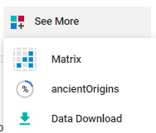
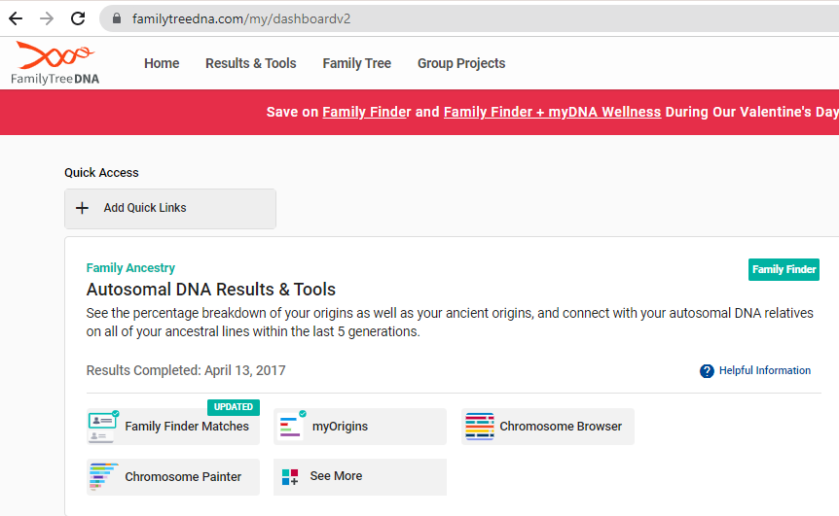
Click “See More, then click “Data Download.”
Then choose “Build 37…” on the far right.

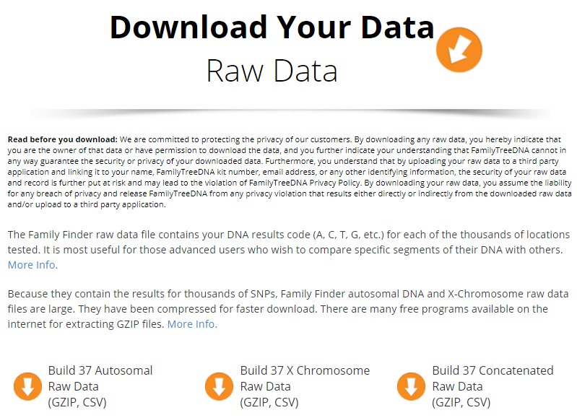

- Once you click “Build 37 Concatenated Raw DNA,” go to GEDmatch.com.
- If you have already created an account at GEDmatch.com, open GEDmatch.com. Use the “Upload your DNA files (below), CLICK “Generic Uploads (23andMe, FTDNA, AncestryDNA, most others).
- Fill in the name of the donor, etc., then click “Choose File,” and look in your downloads for the DNA file, DOUBLE-CLICK, give it time to load (a few seconds), then click “Upload” – WAIT, you will see another screen, and GEDmatch is ‘populating’ your DNA data, then give you a GEDmatch Kit #.
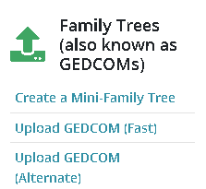
5. Download your public family tree into a GEDcom File.
- On Ancestry.com, click the Trees tab and select a tree.
- In the dropdown toolbar, click “Settings”.
- On the right side of the Tree Settings page, under “Manage your tree”, click “Export tree.” If you see Download your GEDCOM file, skip to step 5.
- The button will begin generating a GEDCOM file.
- When it stops spinning, click Download Your GEDCOM File.
- Upload your GEDcom file to GEDmatch.com.

6. To participate in an optional “Live” GEDmatch Demonstration, bring your kit # to the event! Or email your name and kit # to Patti at EnthusiasticGenealogist@gmail.com.

The “Live GEDmatch Demonstration” will include four of the FREE tools:
- Are Your Parents Related?
- One-to-Many – Original Version
- One-to-One Autosomal DNA Comparison
- People Who Match Both, or 1 of 2 Kits

